Practical-4

Assume JK Enterprises organization wants to set up an organization tree. Organization is planning to use ISIM to add organizational units for Sales, Finance and Development. They also want to add locations under the sales organizational unit for worldwide, Americas, Europe and Asia Pacific.Organization also wants to add business partner units(TechSupport).

Theory:-

* Directory Information Tree (DIT):-

A directory information tree (DIT) is data represented in a hierarchical tree-like structure consisting of the Distinguished Names (DNs) of directory service entries.

Both the X.500 protocols and the Lightweight Directory Access Protocol (LDAP) use directory information trees as their fundamental data structure.

Typically, an X.500 or LDAP deployment for a single organization will have a directory information tree that consists of two parts:

>> a top level name structure for the name of the organization itself

>> a representation of the data model structure within the organization

* LDAP Schema

A directory schema specifies, among other rules, the types of objects that a directory may have and the mandatory and optional attributes of each object type. The Lightweight Directory Access Protocol (LDAP) version 3 defines a schema based on the X.500 standard for common objects found in a network, such as countries, localities, organizations, people, groups, and devices. In the LDAP v3, the schema is available from the directory. That is, it is represented as entries in the directory and its information as attributes of those entries.

**Tasks to be done:**

1. Adding the organizational units
2. Adding the locations units
3. Adding a business partner unit
4. **Adding the organizational units**

* Log in to the IBM Security Identity Manager Administrative Console (ISIM Console Bookmark) as the system administrator

(<https://isim.test:9443/itim/console/main>)

user ID: itim

password: P@ssw0rd

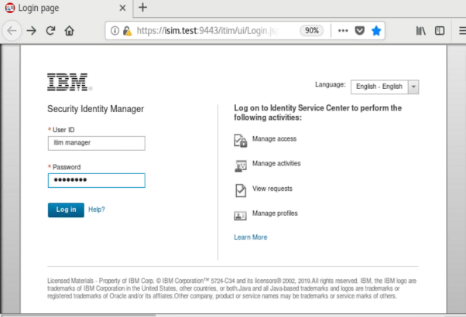

* On the Home tab, Click Manage Organization Structure

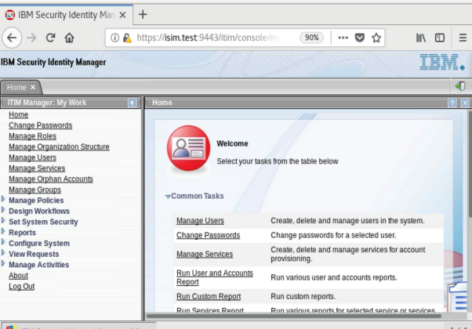

* Click the plus (+) sign to the left of the house icon to expand the selection. Click the small triangle to the right of the organization JK Enterprises and click Create Organizational Unit.

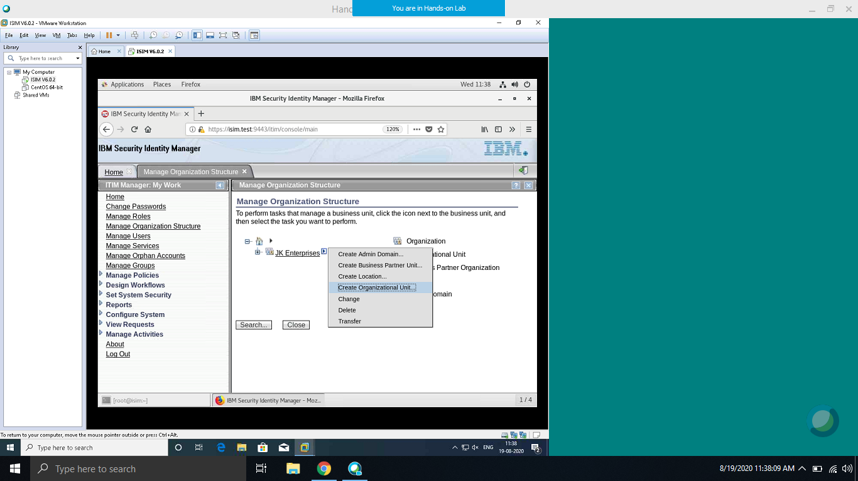

* Complete the Organizational Unit form:

|  |  |
| --- | --- |
| Field | Value |
| Organizational name unit | Sales1 |
| Description | Sales1 Organisational unit |
| Supervisor | System Administrator |

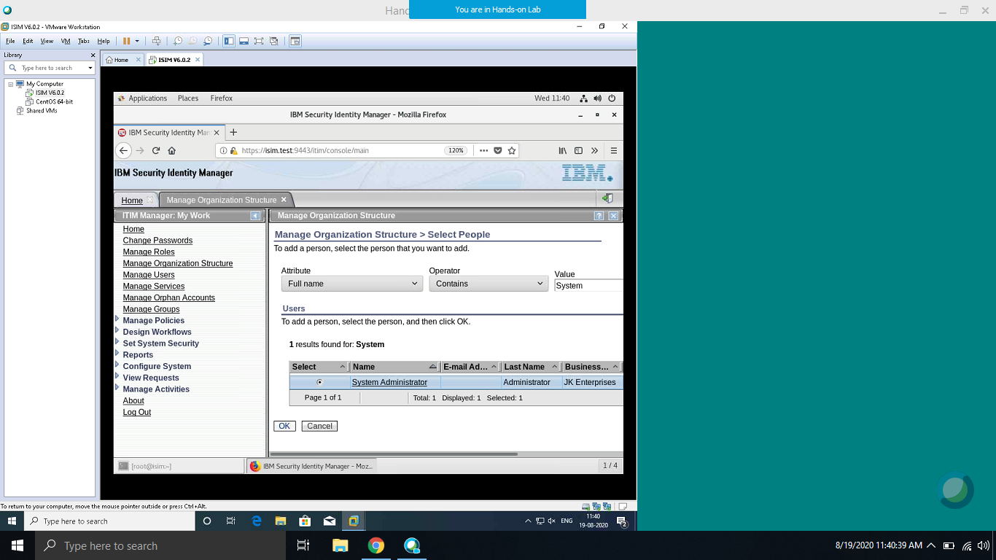

Note: To populate the Supervisor field, click Search and complete the search form to look for a Full Name that contains the word System. Click Search. The search returns the user System Administrator. Select System Administrator and click OK.

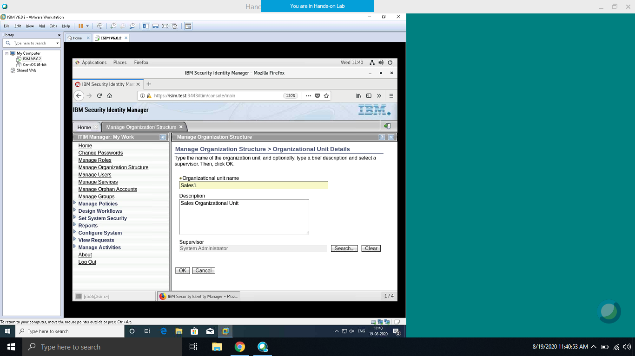

Sales1 is added Successfully.

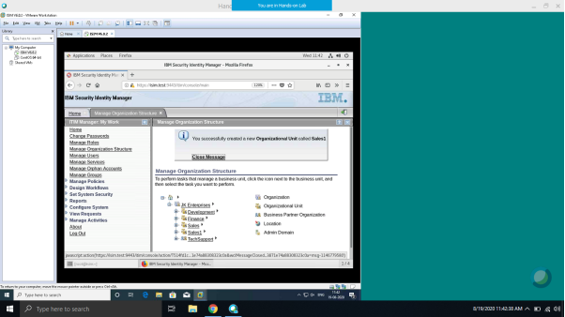

* Click OK. Refresh Manage Organization Structure tab to see new entry.

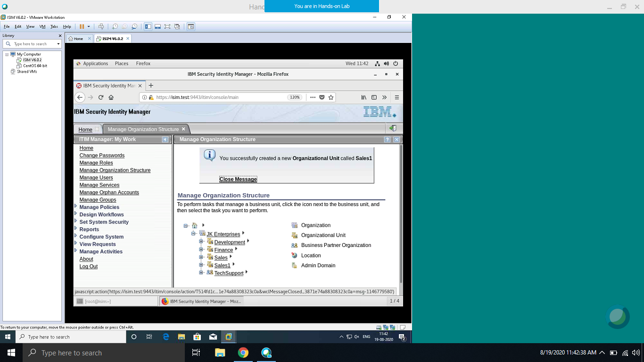

* Repeat steps to create the Finance1 and Development1 organizational units.

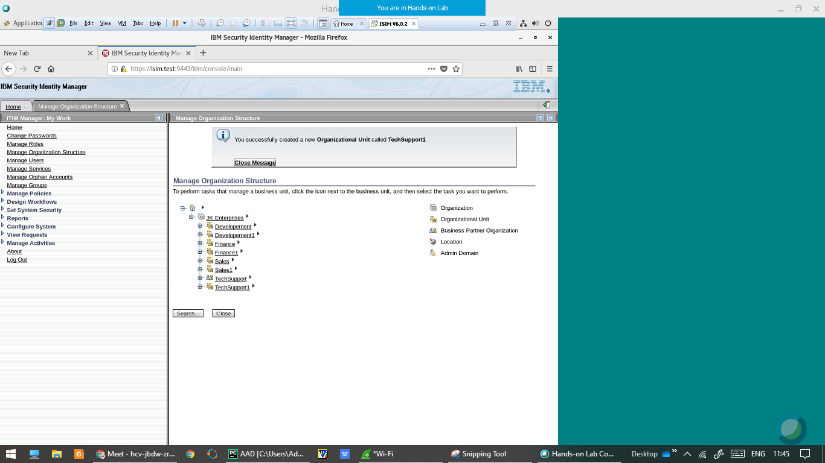

1. **Adding the locations units**

The sales organization for JKE is divided into four regions: WW, Americas, EMEA, and AP. The administration of users and resources is also divided into the same four regions. Therefore, a logical design choice is to create locations of the Sales organization tree branch to contain the users in these regions.

* Click the triangle to the right of JK Enterprises > Sales1 and click Create Location.

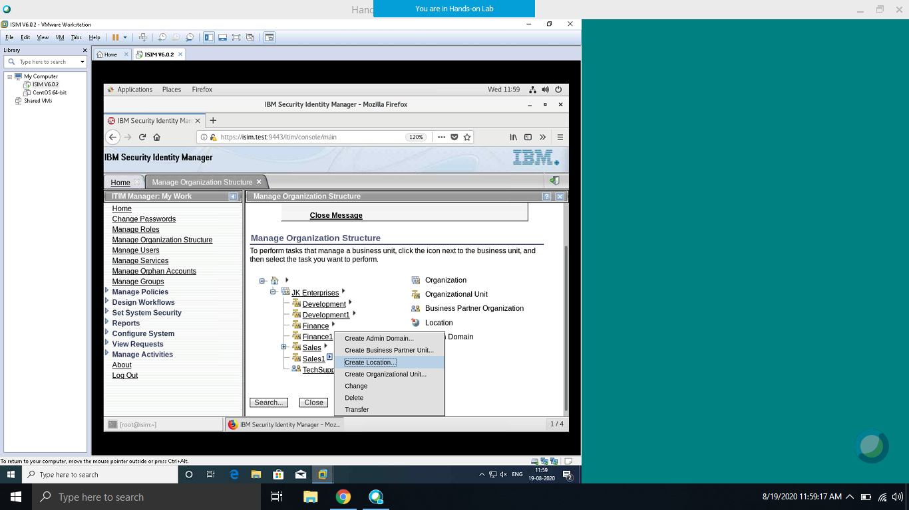

* You complete the Location Details form with the following information:

|  |  |
| --- | --- |
| Field | Value |
| Location Name | WW |
| Description | World Wide |
| Supervisor | System Administrator |

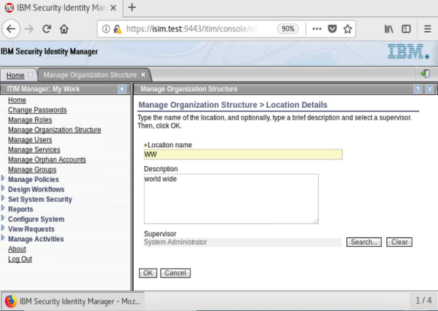

* Click OK.

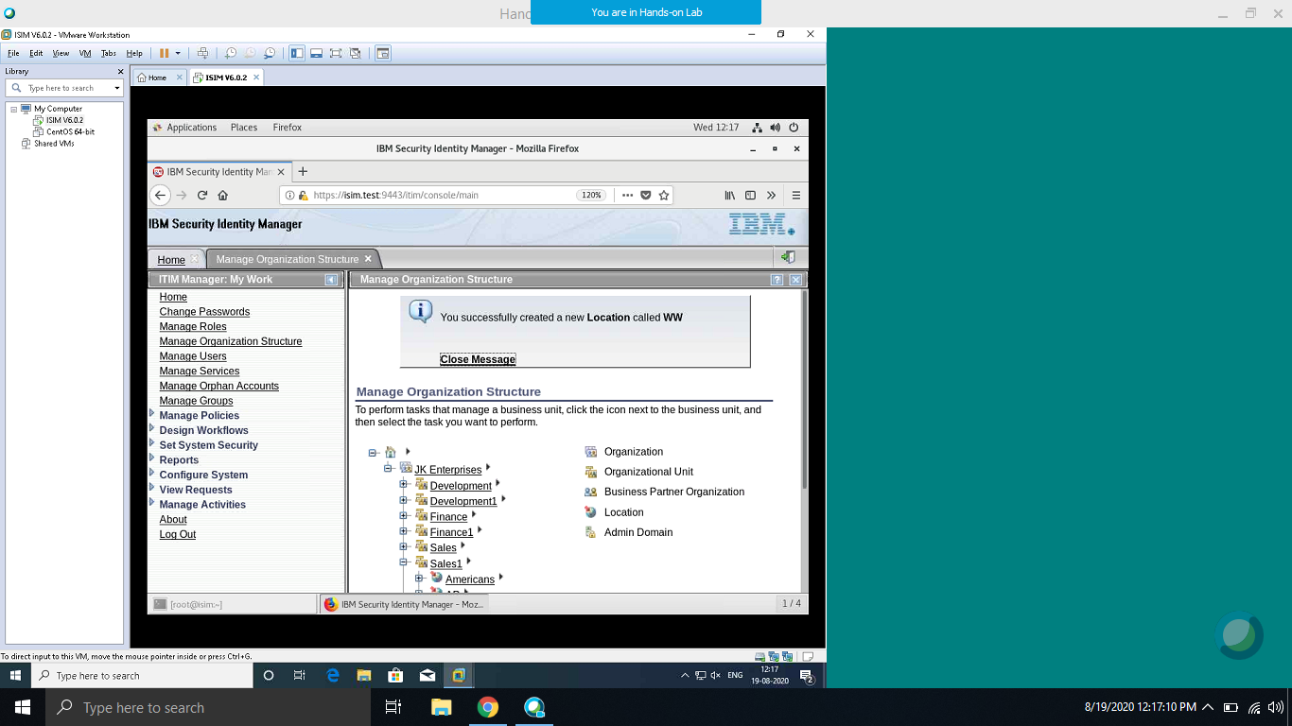

* Repeat steps for the remaining locations:

- Americas

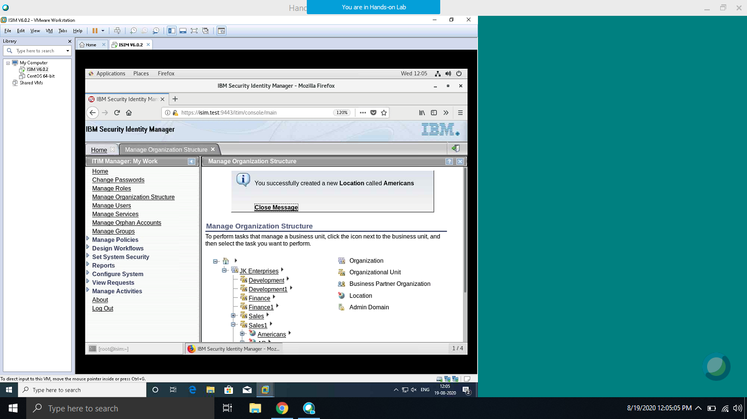

- EMEA

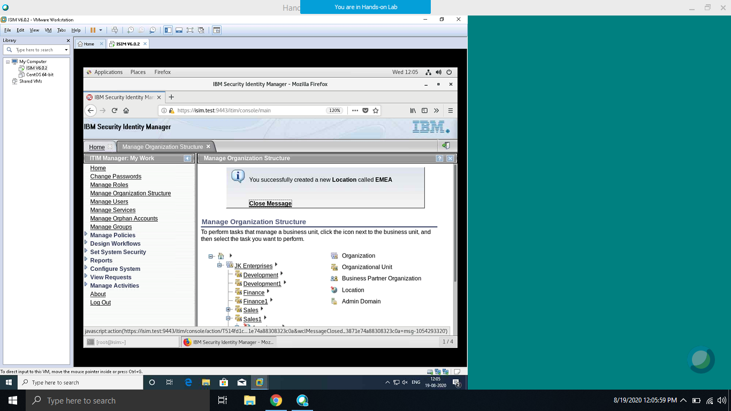

- AP

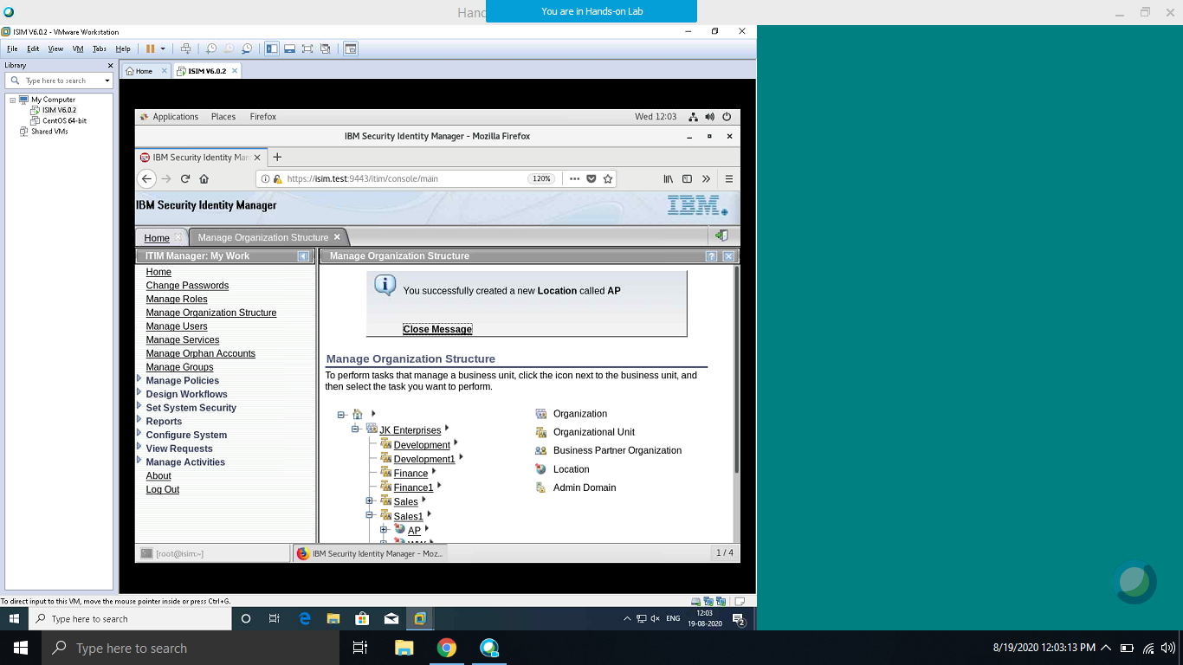

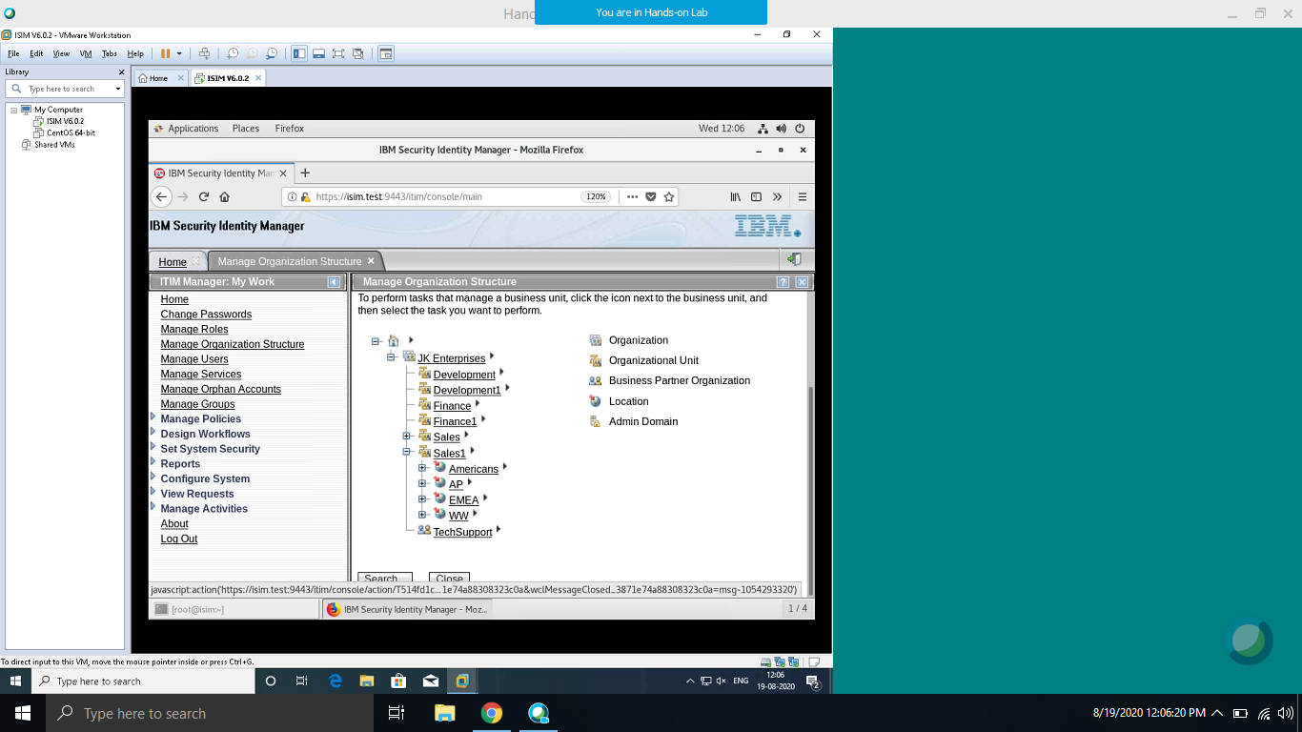

1. **Adding a business partner unit**

JKE outsourced its support operations to a company called TechSupport1. Employees of TechSupport1 require access to JKE resources. Therefore, we create a business partner organization of the JK Enterprises branch.

* Click the arrow to the right of JK Enterprises and click Create Business Partner Unit.

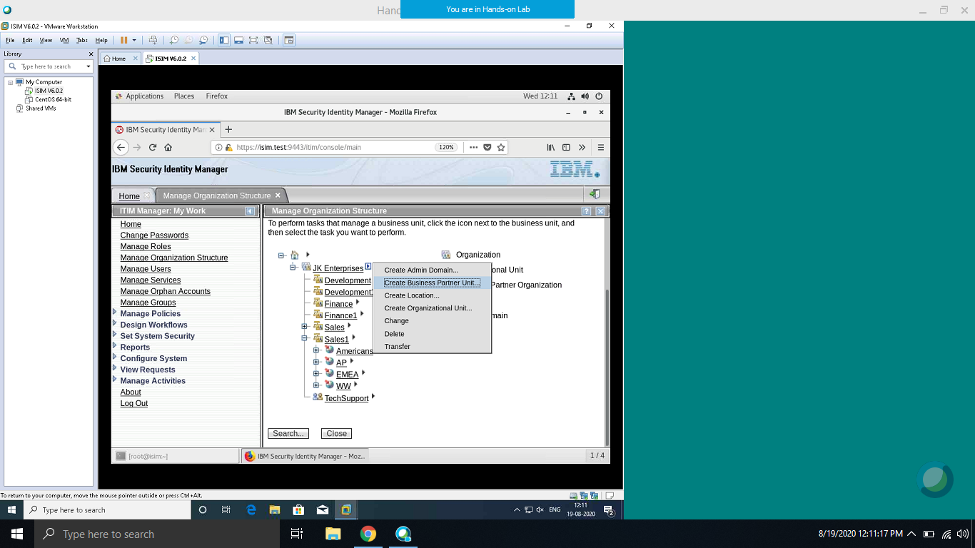

* Complete the Business Partner Unit form with the following information:

|  |  |
| --- | --- |
| Field | Value |
| Business Partner Name | TechSupport1 |
| Sponsor | System Administrator |

Selecting Sponsor

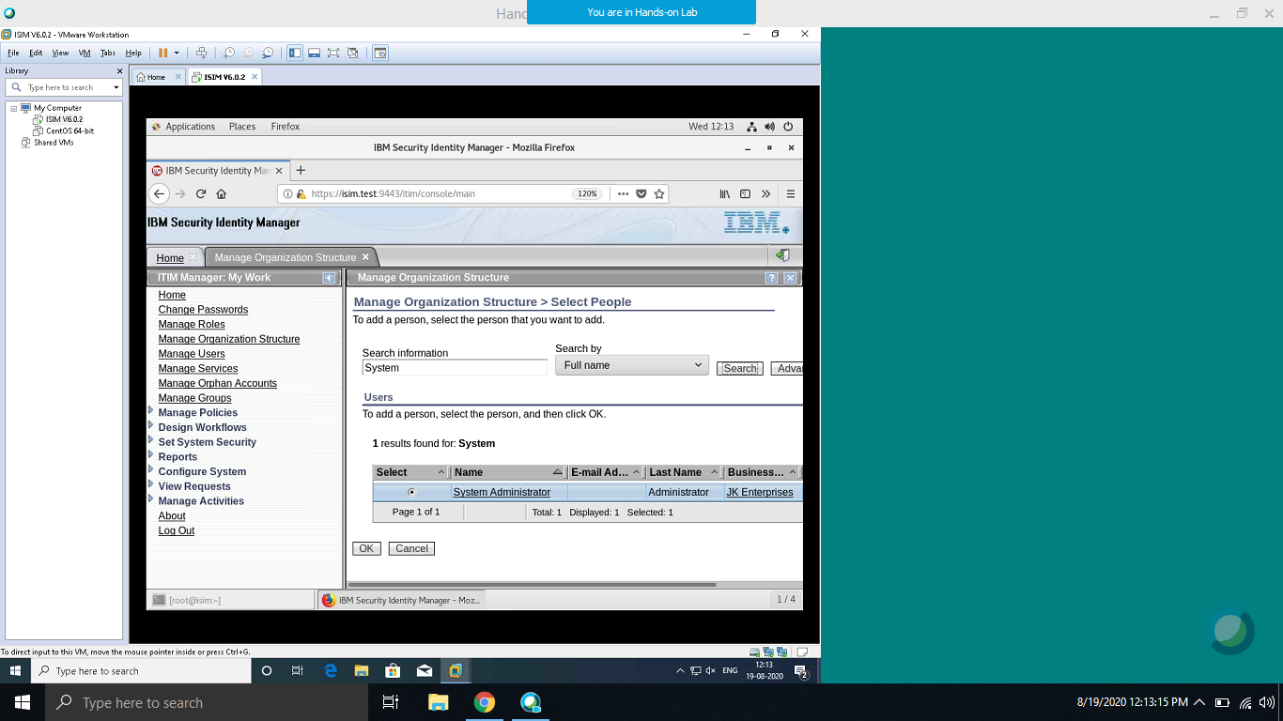

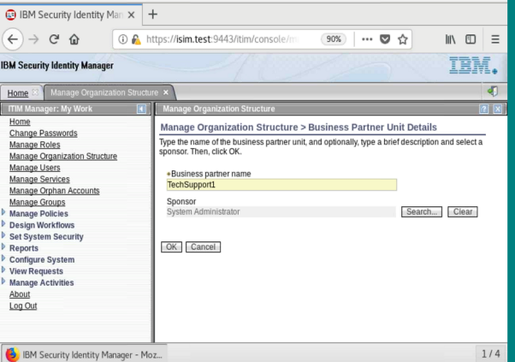

* Click OK
* Final Subtree:-

